Make your own Beastie!
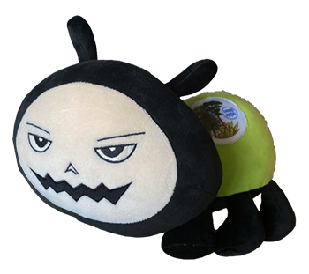

Beastie the Bug is an invasive pest travelling the world to raise awareness on plant health during the International Year of Plant Health #IYPH2020.
This little mascot was created by the European and Mediterranean Plant Protection Organization (EPPO). You can follow how Beastie is spreading worldwide by following the Twitter account (@bug_beastie) and at https://beastiebug.eppo.int.

Follow the instructions below and discover how to prepare a lovely Beastie with your kids based on a camembert box.

What you need:
- a camembert box (or a box of a similar size)
- a pair of scissors
- felt tip pens
- glue
- a piece of thick paper/thin cardboard

Thanks to Camille (EPPO) for this idea!
We would be happy to see your Camembugs, please send them via Twitter or by email to iyph@eppo.int. If you wish to share other DIYs, contact us!
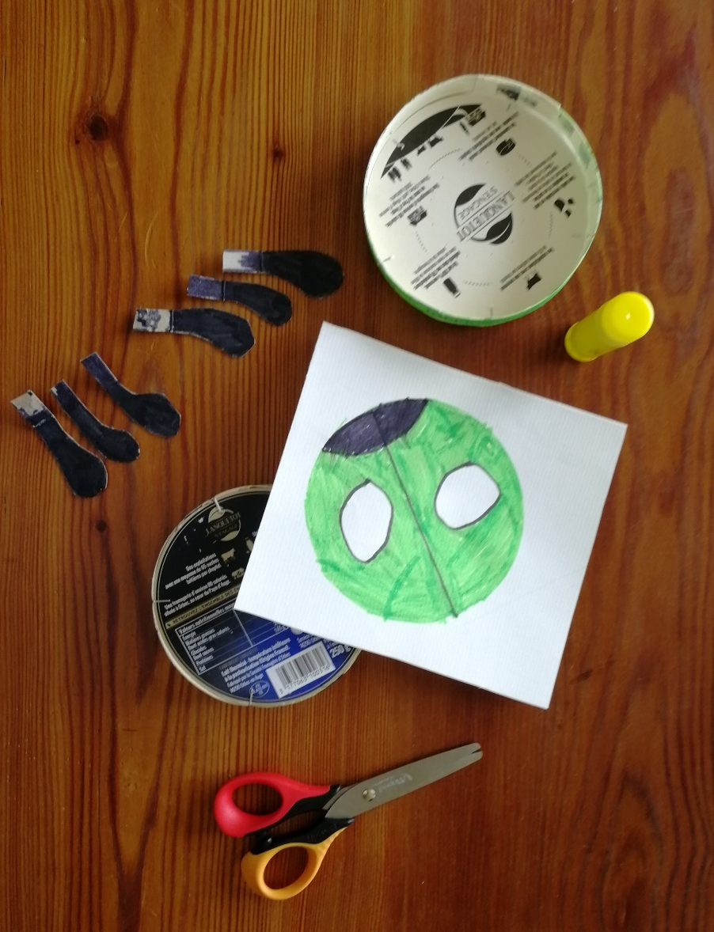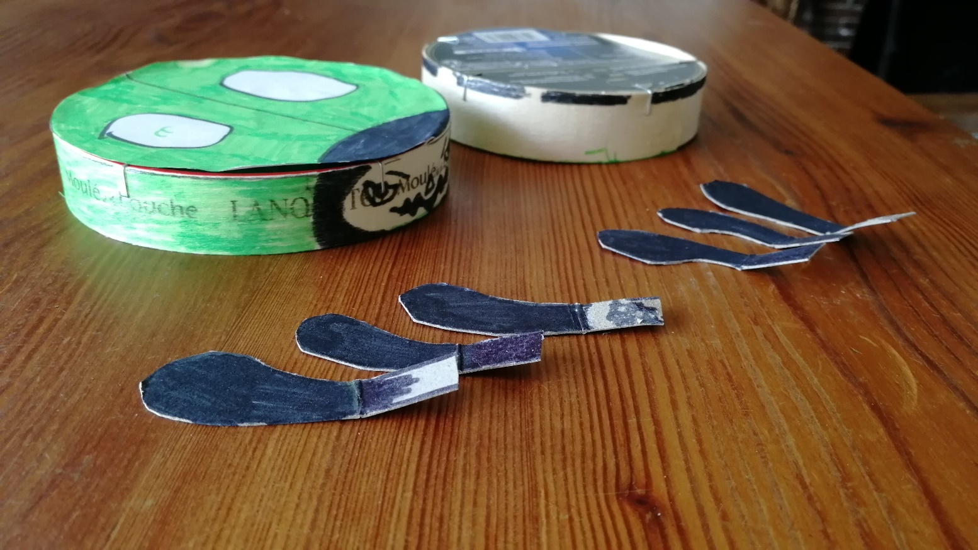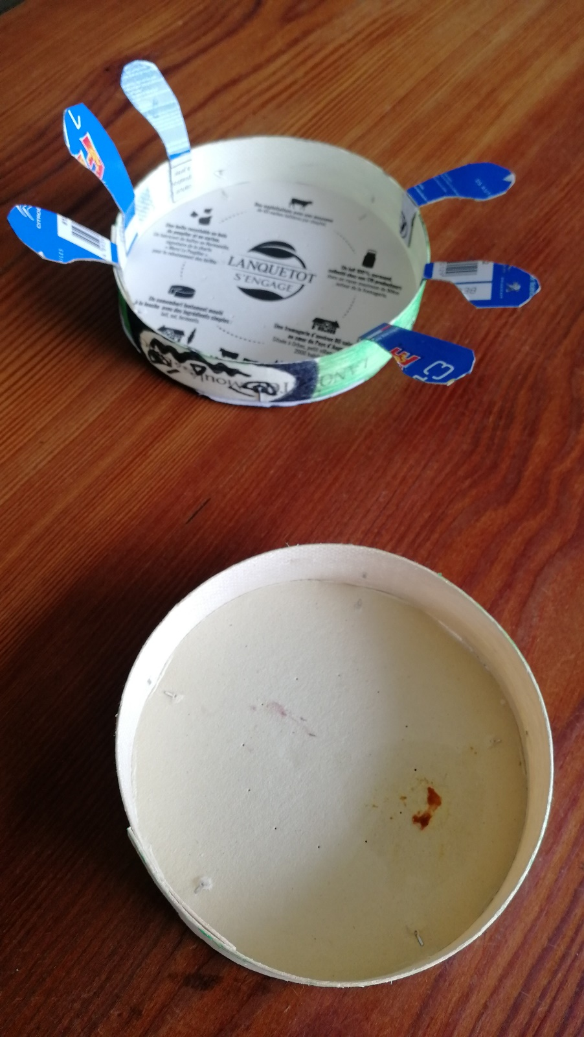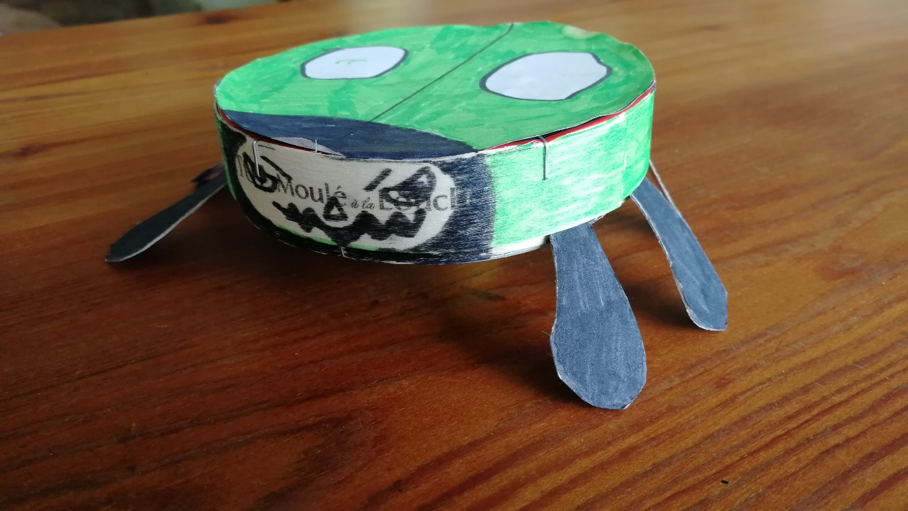
First, cut out 6 legs from a thick piece of paper. Colour them in black.
On another piece of paper, use the lid of the camembert box to draw a circle with a pencil. Colour it in green with a felt tip pen and leave out some white spots if you like. Draw a line through the middle and at one end of this line, draw a small edge of a circle, for the top of Beastie’s head. Colour it in black
Cut out your circle, representing Beastie’s back, using scissors. Stick it on the lid of the camembert box.
Then, draw Beastie’s face on the side of the lid, using a black felt tip pen. Don’t forget to give him that evil look (grrrrr). Colour the rest of the side of the lid in green.
Now, turn the lid upside down. On each side of Beastie, stick three legs to the inside of the lid. Be sure to attach the thin end of the leg, so Beastie’s feet stick out!
Turn him around and there you go ! Your very own Camembug ! Be careful, he is an evil invasive bug, and he bites ! Grrrrr

